ИИН 930911401447
Ватсап телефоны 77750477193

ӘБДІҚАДЫРОВА Ғазиза Ердәулетқызы,
Нұр-Болашақ-2 мектебінің ағылшын тілі пәні мұғалімі.
Түркістан қаласы

TRAVEL

Learning objectives | 5.2.2.1 understand an increasing range of unsupported basic questions which ask for personal information;  5.3.6.1 communicate meaning clearly at sentence level during, pair, group and whole class exchanges;  5.6.9.1 use simple present and imperatives to describe holiday activities;
Lesson objectives | Learners will be able to:  • Learn and practise verbs to talk about holidays.  • Learn and practise the imperative.  • Practise talking about what tourists can do in your country
Plan

Stages/Time | Teachers’ actions | Students’ actions | Assessment criteria | Resources
Beginning of the lesson  Warming-up  3 min.    3min.  2 min. | Organization moment  1.Greeting.  Ask about the weather.  Warm-up  Do short meditation.    The teacher check home task  Students let's divide the into two groups using the suitcase method  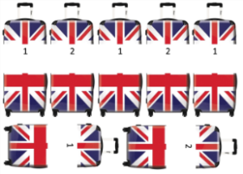  Lead – In  The teacher showed a video about the trip | Students' attention is drawn to the lesson and meditate  After meditation, students visualize their emotions  Students read sentences  Students are divided into two groups  Students watch a video about travel and guess the topic of the lesson | Formative Assessment  Exellent!  Good job!  Not bad! | Video  On copybook  Video about TRIP
5 min.  10 min.  5 min.  5 min.  9 min. | Learn the new words  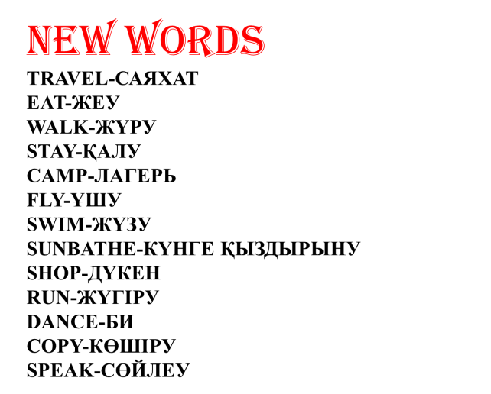  Task 1 pg 82 Listening  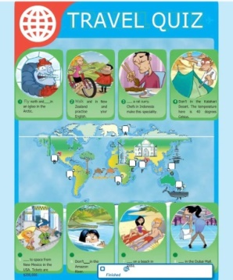  Task 2 Task of the wordwall platform.  The teacher plays music  Task3  Choose the card read and complete the task  Task 4  Before do Ex: 5 P:82 teacher explain the grammar theme of the lesson  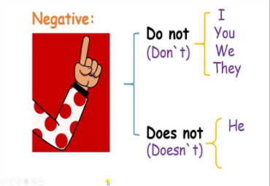  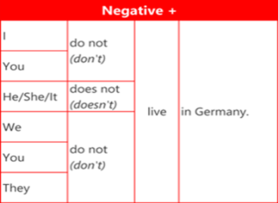  Relaxion time  Students play an interesting game using the CUP method    Task 5 with group  «Suitcase»  Conclusion during the lesson some tasks differentiated by outcomes of the students and by their abilities.  Assessment of students  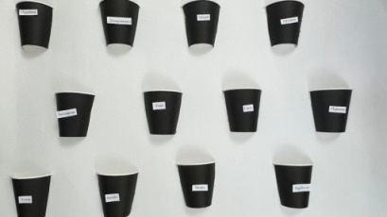 | Student study the new word  Students listen to the audio and put the necessary words in their place  Students give each other the airplane. Completes the task when the music stop  ANSWERS  1 a  2 b  3b  4a  5a  6a  7c  8d  9a  10b  Laerners are understands grammar  - learners do the quiz and find the correct answers and write them in copybooks  students perform with interest  Students match words and pictures | Descriptor:  -Listening  - put words  Descriptor:  -be quick  - find the correct answers  -choose correct answer  Descriptor:  -can do the quiz  - find the correct answers  Descriptor:  -be quick  Match words and pictures  Exellent!  Good job!  Not bad! | Presentation    Studentsbook  Wordwall  Work with board  Slide  Game  
End  3 min. | FEEDBACK  Learners provide feedback on what they have learned at the lesson | Children give feedback by drawing a picture of an airplane |  | Paper

